BASIL M. POULOSE

MARACHERY PUTHAYATHU
NERIAMANAGALAM PO
KADIKKANDAM
PH: 9562975864
e- mail: basilmp10@gmail.com

CAREER OBJECTIVE
To seek a rewarding position in a business organization which will capitalize my accumulated knowledge and skill and which provides me with an opportunity for professional growth in the business sector .
WORK EXPERIENCE
1 year and 10months’experience as a sales consultant in automobile industry . I have been working in Kerala Cars Pvt Ltd since 1st December 2013 as Sales Consultant . Before that I had worked for 1 year in Popular Motor World Pvt Ltd as Sales Advisor
ACADEMIC PROFILE

COURSE | INSTITUTION | UNIVERSITY | PERCENTAGE  OBTAINED | DURATION
MBA  Marketing & HRM | Marian Academy of Management Studies, | MG University, Kottayam | 68% | 2011-2013
Graduation -  B.Com with CA | Yeldo Mar Baselios College, Kothamangalam | M.G University, Kottayam | 68 % | 2008- 2011
Higher Secondary ,  Commerce | Mar Basil H.S.S, Kothamanagalam | Board of Higher Secondary Examination | 70% | March 2008
SSLC | Mar Basil H.S.S, Kothamangalam | Board of Public Examination | 64 % | March 2006

COMPUTER AWARNESS
- MS Office, Tally, Visual Basic, MS Access

ACHIVEMENTS
Performer in Kerala Cars Pvt Ltd and Popular Motor World Pvt Ltd . Arts Day celebration in Marian Academy of Management Studies in 2012-2013

LANGUAGES KNOWN

Language | Speak | Read & Write | Understand
Malayalam
English

PERSONAL DETAILS
Age : 23
Date of Birth : 31-10-1990
Sex : Male
Nationality : Indian
Marital Status : Single

REFERENCES
Lathesh N.V Shinto George
Sales Manager Zonal Head
Popular Motor World Pvt Ltd Kerala Cars Pvt Ltd
Muvatupuzha Edappally
Ph: 9447080506 Ph: 8138014455

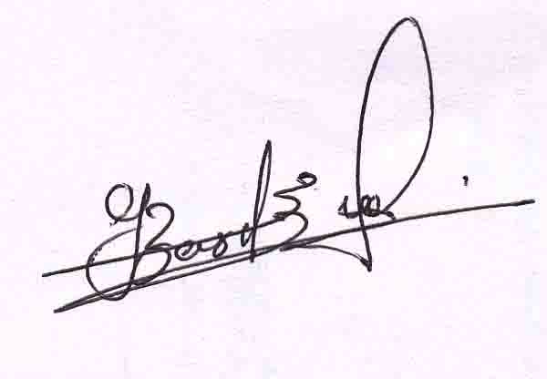
BASIL M POULOSE
PLACE: Neriamangalam
Date :1-11-2014

